**Appendix**

HIT Page Instructions

Play an easy button-pressing game for academic research. You will earn base pay = $0.50. Bonus pay from in-game points could earn you even more for more optimal performances. A simple survey follows about your participation. Click the link below to begin. At the end of the game, you will receive a payment code. Paste the code into the box below to receive payment.

This HIT must be completed on a**WINDOWS**or **MAC COMPUTER**with one of the following browsers: **GOOGLE CHROME**, **MOZILLA FIREFOX**, or **MICROSOFT EDGE**.

**Make sure to leave this window open as you play the game.**When you complete the HIT, return to this page to paste the **PAYMENT CODE** **(NOT YOUR WORKER ID)** into the box.

Task Instructions

Page 1: Hello and thank you for choosing this HIT! IMPORTANT: Please read the following instructions before beginning!

1. Payment for participating requires you stay on this tab of your web browser for the entire duration of the HIT. Please close any other tabs that you have open that could distract you. We use server-side coding so we will know if and how long you leave the HIT page. You WILL NOT BE PAID for participation if you violate this rule – no exceptions.

2. Do not press the “back page” button or "refresh" button at any time during the HIT. Doing so will end the HIT and your opportunity for payment.

3. Only do this HIT on a laptop or desktop computer – do NOT USE a phone or tablet.

4. Use one of the following web browsers: Google Chrome, Mozilla Firefox, or Microsoft Edge.

5. When the HIT is over, the HIT code will be displayed onscreen for you to enter for payment.

Press this button when ready to continue:

Page 2: After pressing the PROCEED button below, you will play a game to earn as many points as you can. A new page will appear and you will see one or more buttons. Pressing buttons could sometimes increase or decrease your points. Points will be tracked by a bar on the screen.

The game will take approximately 15-20 minutes to complete. If you complete the game, you will be paid for completing the HIT and every point earned will be worth US$0.000235.

Failing to begin engaging with the game within 30 seconds after proceeding will terminate the opportunity to participate in this HIT and the opportunity for payment. Therefore, do not proceed unless you are ready to begin and complete the game.

Press the PROCEED button when ready to continue and please begin the game as soon as the interface appears.

Survey Questions

1) On a scale of 1 (definitely no) to 100 (definitely yes), how sure are you there was a button with a RED HEART at some point during the HIT?

2) On a scale of 1 (definitely no) to 100 (definitely yes), how sure are you there was a button with a BLACK SPADE at some point during the HIT?

3) On a scale of 1 (definitely no) to 100 (definitely yes), how sure are you there was a button with a RED DIAMOND at some point during the HIT?

4) On a scale of 1 (definitely no) to 100 (definitely yes), how sure are you there was a button with a BLACK CLUB at some point during the HIT?

5) On a scale of 1 (not effective) to 100 (very effective), how sure are you the button with a RED HEART was effective for earning points at some point during the HIT?

6) On a scale of 1 (not effective) to 100 (very effective), how sure are you the button with a BLACK SPADE was effective for earning points at some point during the HIT?

7) On a scale of 1 (not effective) to 100 (very effective), how sure are you the button with a RED DIAMOND was effective for earning points at some point during the HIT?

8) On a scale of 1 (not effective) to 100 (very effective), how sure are you the button with a BLACK CLUB was effective for earning points at some point during the HIT?

9) What do you think was the overall purpose of the study you just completed? If you do not know, please feel free to respond, “I don’t know.” Leave the question blank if you prefer not to answer.

10) Did you have an overall strategy that you used throughout the study?

* Yes
* No
* I prefer not to answer.

11) Please describe your overall strategy that you used throughout the study. If you did not have a strategy, please feel free to respond, “I did not have a strategy.” Leave the question blank if you prefer not to answer.

* I did not have a strategy.
* I prefer not to answer.
* My strategy did not change.
* My strategy did change (If so, please describe below how your strategy changed).

12) Did your strategy change as you moved forward in the study?

13) If there is any other information you wish to explain about your experience during the study, please describe here:

14) What is your age?

15) What gender/sex do you identify with?

16) What is your nationality?

17) In what country do you live?

18) How much distress did you feel resulting from this task from 1 (no stress) to 100 (very stressful)?

19) Do you have any problems with color vision?

* No.
* Yes, red-green color blindness.
* Yes, blue-yellow color blindness.
* Yes, total color blindness.
* Yes, other.

**Task Interface**

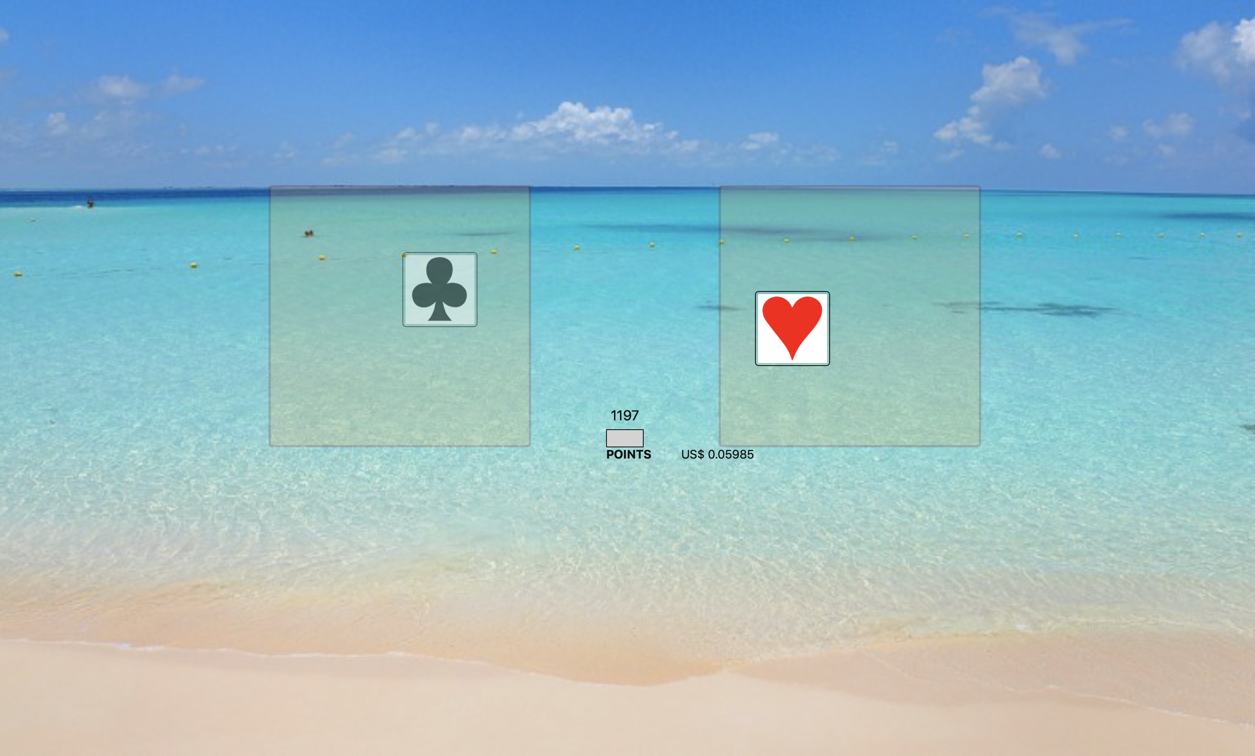

-1

+10

+10



**+100**

An example of objects shown on the browser during the experimental task. Each workspace shown above is 350-px by 350-px. Two buttons (each consisting of a 100 by 100-px square with a superimposed symbol) are also shown. A yellow star with green text (“+100”) is shown above one of the buttons, indicating reinforcement. Red text is shown below the button indicating a response cost (-1 point). A point counter is shown between the two workspaces and total earnings are shown to the right of the point counter.